LAB-2

(DIGITAL SIGNAL PROCESSING)

STUDENT ID :748434

STUDENT NAME: Amandeep Kaur

STUDENT ID :747925

STUDENT NAME: Shweta Gulati

**1. Create a 2Dimesional plot of sine function between 0 to 2pi.**

>> l=[0:0.1:2*pi]

l =

Columns 1 through 14:

0.00000 0.10000 0.20000 0.30000 0.40000 0.50000 0.60000 0.70000 0.80000 0.90000 1.00000 1.10000 1.20000 1.30000

Columns 15 through 28:

1.40000 1.50000 1.60000 1.70000 1.80000 1.90000 2.00000 2.10000 2.20000 2.30000 2.40000 2.50000 2.60000 2.70000

Columns 29 through 42:

2.80000 2.90000 3.00000 3.10000 3.20000 3.30000 3.40000 3.50000 3.60000 3.70000 3.80000 3.90000 4.00000 4.10000

Columns 43 through 56:

4.20000 4.30000 4.40000 4.50000 4.60000 4.70000 4.80000 4.90000 5.00000 5.10000 5.20000 5.30000 5.40000 5.50000

Columns 57 through 63:

5.60000 5.70000 5.80000 5.90000 6.00000 6.10000 6.20000

>> m=sine(l)

error: 'sine' undefined near line 1 column 3

>> m=sin(l)

m =

Columns 1 through 14:

0.00000 0.09983 0.19867 0.29552 0.38942 0.47943 0.56464 0.64422 0.71736 0.78333 0.84147 0.89121 0.93204 0.96356

Columns 15 through 28:

0.98545 0.99749 0.99957 0.99166 0.97385 0.94630 0.90930 0.86321 0.80850 0.74571 0.67546 0.59847 0.51550 0.42738

Columns 29 through 42:

0.33499 0.23925 0.14112 0.04158 -0.05837 -0.15775 -0.25554 -0.35078 -0.44252 -0.52984 -0.61186 -0.68777 -0.75680 -0.81828

Columns 43 through 56:

-0.87158 -0.91617 -0.95160 -0.97753 -0.99369 -0.99992 -0.99616 -0.98245 -0.95892 -0.92581 -0.88345 -0.83227 -0.77276 -0.70554

Columns 57 through 63:

-0.63127 -0.55069 -0.46460 -0.37388 -0.27942 -0.18216 -0.08309

>> plot(l,m)

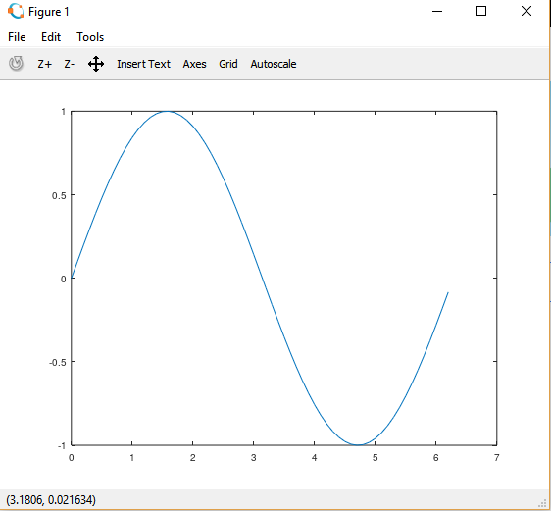

**2.Create a 3D plot of a surface by creating a grid along the X and Y axes and plotting the Z-coordinate according to the exponential function.**

>> [x,y]=meshgrid(-1:0.1:1)

x =

Columns 1 through 9:

-1.00000 -0.90000 -0.80000 -0.70000 -0.60000 -0.50000 -0.40000 -0.30000 -0.20000

-1.00000 -0.90000 -0.80000 -0.70000 -0.60000 -0.50000 -0.40000 -0.30000 -0.20000

-1.00000 -0.90000 -0.80000 -0.70000 -0.60000 -0.50000 -0.40000 -0.30000 -0.20000

-1.00000 -0.90000 -0.80000 -0.70000 -0.60000 -0.50000 -0.40000 -0.30000 -0.20000

-1.00000 -0.90000 -0.80000 -0.70000 -0.60000 -0.50000 -0.40000 -0.30000 -0.20000

-1.00000 -0.90000 -0.80000 -0.70000 -0.60000 -0.50000 -0.40000 -0.30000 -0.20000

-1.00000 -0.90000 -0.80000 -0.70000 -0.60000 -0.50000 -0.40000 -0.30000 -0.20000

-1.00000 -0.90000 -0.80000 -0.70000 -0.60000 -0.50000 -0.40000 -0.30000 -0.20000

-1.00000 -0.90000 -0.80000 -0.70000 -0.60000 -0.50000 -0.40000 -0.30000 -0.20000

-1.00000 -0.90000 -0.80000 -0.70000 -0.60000 -0.50000 -0.40000 -0.30000 -0.20000

-1.00000 -0.90000 -0.80000 -0.70000 -0.60000 -0.50000 -0.40000 -0.30000 -0.20000

-1.00000 -0.90000 -0.80000 -0.70000 -0.60000 -0.50000 -0.40000 -0.30000 -0.20000

-1.00000 -0.90000 -0.80000 -0.70000 -0.60000 -0.50000 -0.40000 -0.30000 -0.20000

-1.00000 -0.90000 -0.80000 -0.70000 -0.60000 -0.50000 -0.40000 -0.30000 -0.20000

-1.00000 -0.90000 -0.80000 -0.70000 -0.60000 -0.50000 -0.40000 -0.30000 -0.20000

-1.00000 -0.90000 -0.80000 -0.70000 -0.60000 -0.50000 -0.40000 -0.30000 -0.20000

-1.00000 -0.90000 -0.80000 -0.70000 -0.60000 -0.50000 -0.40000 -0.30000 -0.20000

-1.00000 -0.90000 -0.80000 -0.70000 -0.60000 -0.50000 -0.40000 -0.30000 -0.20000

-1.00000 -0.90000 -0.80000 -0.70000 -0.60000 -0.50000 -0.40000 -0.30000 -0.20000

-1.00000 -0.90000 -0.80000 -0.70000 -0.60000 -0.50000 -0.40000 -0.30000 -0.20000

-1.00000 -0.90000 -0.80000 -0.70000 -0.60000 -0.50000 -0.40000 -0.30000 -0.20000

Columns 10 through 18:

-0.10000 0.00000 0.10000 0.20000 0.30000 0.40000 0.50000 0.60000 0.70000

-0.10000 0.00000 0.10000 0.20000 0.30000 0.40000 0.50000 0.60000 0.70000

-0.10000 0.00000 0.10000 0.20000 0.30000 0.40000 0.50000 0.60000 0.70000

-0.10000 0.00000 0.10000 0.20000 0.30000 0.40000 0.50000 0.60000 0.70000

-0.10000 0.00000 0.10000 0.20000 0.30000 0.40000 0.50000 0.60000 0.70000

-0.10000 0.00000 0.10000 0.20000 0.30000 0.40000 0.50000 0.60000 0.70000

-0.10000 0.00000 0.10000 0.20000 0.30000 0.40000 0.50000 0.60000 0.70000

-0.10000 0.00000 0.10000 0.20000 0.30000 0.40000 0.50000 0.60000 0.70000

-0.10000 0.00000 0.10000 0.20000 0.30000 0.40000 0.50000 0.60000 0.70000

-0.10000 0.00000 0.10000 0.20000 0.30000 0.40000 0.50000 0.60000 0.70000

-0.10000 0.00000 0.10000 0.20000 0.30000 0.40000 0.50000 0.60000 0.70000

-0.10000 0.00000 0.10000 0.20000 0.30000 0.40000 0.50000 0.60000 0.70000

-0.10000 0.00000 0.10000 0.20000 0.30000 0.40000 0.50000 0.60000 0.70000

-0.10000 0.00000 0.10000 0.20000 0.30000 0.40000 0.50000 0.60000 0.70000

-0.10000 0.00000 0.10000 0.20000 0.30000 0.40000 0.50000 0.60000 0.70000

-0.10000 0.00000 0.10000 0.20000 0.30000 0.40000 0.50000 0.60000 0.70000

-0.10000 0.00000 0.10000 0.20000 0.30000 0.40000 0.50000 0.60000 0.70000

-0.10000 0.00000 0.10000 0.20000 0.30000 0.40000 0.50000 0.60000 0.70000

-0.10000 0.00000 0.10000 0.20000 0.30000 0.40000 0.50000 0.60000 0.70000

-0.10000 0.00000 0.10000 0.20000 0.30000 0.40000 0.50000 0.60000 0.70000

-0.10000 0.00000 0.10000 0.20000 0.30000 0.40000 0.50000 0.60000 0.70000

Columns 19 through 21:

0.80000 0.90000 1.00000

0.80000 0.90000 1.00000

0.80000 0.90000 1.00000

0.80000 0.90000 1.00000

0.80000 0.90000 1.00000

0.80000 0.90000 1.00000

0.80000 0.90000 1.00000

0.80000 0.90000 1.00000

0.80000 0.90000 1.00000

0.80000 0.90000 1.00000

0.80000 0.90000 1.00000

0.80000 0.90000 1.00000

0.80000 0.90000 1.00000

0.80000 0.90000 1.00000

0.80000 0.90000 1.00000

0.80000 0.90000 1.00000

0.80000 0.90000 1.00000

0.80000 0.90000 1.00000

0.80000 0.90000 1.00000

0.80000 0.90000 1.00000

0.80000 0.90000 1.00000

y =

Columns 1 through 9:

-1.00000 -1.00000 -1.00000 -1.00000 -1.00000 -1.00000 -1.00000 -1.00000 -1.00000

-0.90000 -0.90000 -0.90000 -0.90000 -0.90000 -0.90000 -0.90000 -0.90000 -0.90000

-0.80000 -0.80000 -0.80000 -0.80000 -0.80000 -0.80000 -0.80000 -0.80000 -0.80000

-0.70000 -0.70000 -0.70000 -0.70000 -0.70000 -0.70000 -0.70000 -0.70000 -0.70000

-0.60000 -0.60000 -0.60000 -0.60000 -0.60000 -0.60000 -0.60000 -0.60000 -0.60000

-0.50000 -0.50000 -0.50000 -0.50000 -0.50000 -0.50000 -0.50000 -0.50000 -0.50000

-0.40000 -0.40000 -0.40000 -0.40000 -0.40000 -0.40000 -0.40000 -0.40000 -0.40000

-0.30000 -0.30000 -0.30000 -0.30000 -0.30000 -0.30000 -0.30000 -0.30000 -0.30000

-0.20000 -0.20000 -0.20000 -0.20000 -0.20000 -0.20000 -0.20000 -0.20000 -0.20000

-0.10000 -0.10000 -0.10000 -0.10000 -0.10000 -0.10000 -0.10000 -0.10000 -0.10000

0.00000 0.00000 0.00000 0.00000 0.00000 0.00000 0.00000 0.00000 0.00000

0.10000 0.10000 0.10000 0.10000 0.10000 0.10000 0.10000 0.10000 0.10000

0.20000 0.20000 0.20000 0.20000 0.20000 0.20000 0.20000 0.20000 0.20000

0.30000 0.30000 0.30000 0.30000 0.30000 0.30000 0.30000 0.30000 0.30000

0.40000 0.40000 0.40000 0.40000 0.40000 0.40000 0.40000 0.40000 0.40000

0.50000 0.50000 0.50000 0.50000 0.50000 0.50000 0.50000 0.50000 0.50000

0.60000 0.60000 0.60000 0.60000 0.60000 0.60000 0.60000 0.60000 0.60000

0.70000 0.70000 0.70000 0.70000 0.70000 0.70000 0.70000 0.70000 0.70000

0.80000 0.80000 0.80000 0.80000 0.80000 0.80000 0.80000 0.80000 0.80000

0.90000 0.90000 0.90000 0.90000 0.90000 0.90000 0.90000 0.90000 0.90000

1.00000 1.00000 1.00000 1.00000 1.00000 1.00000 1.00000 1.00000 1.00000

Columns 10 through 18:

-1.00000 -1.00000 -1.00000 -1.00000 -1.00000 -1.00000 -1.00000 -1.00000 -1.00000

-0.90000 -0.90000 -0.90000 -0.90000 -0.90000 -0.90000 -0.90000 -0.90000 -0.90000

-0.80000 -0.80000 -0.80000 -0.80000 -0.80000 -0.80000 -0.80000 -0.80000 -0.80000

-0.70000 -0.70000 -0.70000 -0.70000 -0.70000 -0.70000 -0.70000 -0.70000 -0.70000

-0.60000 -0.60000 -0.60000 -0.60000 -0.60000 -0.60000 -0.60000 -0.60000 -0.60000

-0.50000 -0.50000 -0.50000 -0.50000 -0.50000 -0.50000 -0.50000 -0.50000 -0.50000

-0.40000 -0.40000 -0.40000 -0.40000 -0.40000 -0.40000 -0.40000 -0.40000 -0.40000

-0.30000 -0.30000 -0.30000 -0.30000 -0.30000 -0.30000 -0.30000 -0.30000 -0.30000

-0.20000 -0.20000 -0.20000 -0.20000 -0.20000 -0.20000 -0.20000 -0.20000 -0.20000

-0.10000 -0.10000 -0.10000 -0.10000 -0.10000 -0.10000 -0.10000 -0.10000 -0.10000

0.00000 0.00000 0.00000 0.00000 0.00000 0.00000 0.00000 0.00000 0.00000

0.10000 0.10000 0.10000 0.10000 0.10000 0.10000 0.10000 0.10000 0.10000

0.20000 0.20000 0.20000 0.20000 0.20000 0.20000 0.20000 0.20000 0.20000

0.30000 0.30000 0.30000 0.30000 0.30000 0.30000 0.30000 0.30000 0.30000

0.40000 0.40000 0.40000 0.40000 0.40000 0.40000 0.40000 0.40000 0.40000

0.50000 0.50000 0.50000 0.50000 0.50000 0.50000 0.50000 0.50000 0.50000

0.60000 0.60000 0.60000 0.60000 0.60000 0.60000 0.60000 0.60000 0.60000

0.70000 0.70000 0.70000 0.70000 0.70000 0.70000 0.70000 0.70000 0.70000

0.80000 0.80000 0.80000 0.80000 0.80000 0.80000 0.80000 0.80000 0.80000

0.90000 0.90000 0.90000 0.90000 0.90000 0.90000 0.90000 0.90000 0.90000

1.00000 1.00000 1.00000 1.00000 1.00000 1.00000 1.00000 1.00000 1.00000

Columns 19 through 21:

-1.00000 -1.00000 -1.00000

-0.90000 -0.90000 -0.90000

-0.80000 -0.80000 -0.80000

-0.70000 -0.70000 -0.70000

-0.60000 -0.60000 -0.60000

-0.50000 -0.50000 -0.50000

-0.40000 -0.40000 -0.40000

-0.30000 -0.30000 -0.30000

-0.20000 -0.20000 -0.20000

-0.10000 -0.10000 -0.10000

0.00000 0.00000 0.00000

0.10000 0.10000 0.10000

0.20000 0.20000 0.20000

0.30000 0.30000 0.30000

0.40000 0.40000 0.40000

0.50000 0.50000 0.50000

0.60000 0.60000 0.60000

0.70000 0.70000 0.70000

0.80000 0.80000 0.80000

0.90000 0.90000 0.90000

1.00000 1.00000 1.00000

>> z=x.*exp(-x^1 - y^1)

z =

Columns 1 through 9:

-7.38906 -6.01730 -4.83972 -3.83176 -2.97182 -2.24084 -1.62208 -1.10079 -0.66402

-6.68589 -5.44468 -4.37916 -3.46712 -2.68901 -2.02760 -1.46772 -0.99604 -0.60083

-6.04965 -4.92655 -3.96243 -3.13718 -2.43312 -1.83465 -1.32805 -0.90125 -0.54366

-5.47395 -4.45773 -3.58535 -2.83864 -2.20158 -1.66006 -1.20167 -0.81548 -0.49192

-4.95303 -4.03352 -3.24416 -2.56851 -1.99207 -1.50208 -1.08731 -0.73788 -0.44511

-4.48169 -3.64968 -2.93544 -2.32408 -1.80250 -1.35914 -0.98384 -0.66766 -0.40275

-4.05520 -3.30237 -2.65609 -2.10292 -1.63097 -1.22980 -0.89022 -0.60413 -0.36442

-3.66930 -2.98811 -2.40333 -1.90280 -1.47576 -1.11277 -0.80550 -0.54664 -0.32974

-3.32012 -2.70375 -2.17463 -1.72172 -1.33532 -1.00688 -0.72885 -0.49462 -0.29836

-3.00417 -2.44645 -1.96768 -1.55788 -1.20825 -0.91106 -0.65949 -0.44755 -0.26997

-2.71828 -2.21364 -1.78043 -1.40963 -1.09327 -0.82436 -0.59673 -0.40496 -0.24428

-2.45960 -2.00299 -1.61100 -1.27548 -0.98923 -0.74591 -0.53994 -0.36642 -0.22103

-2.22554 -1.81238 -1.45770 -1.15410 -0.89509 -0.67493 -0.48856 -0.33155 -0.20000

-2.01375 -1.63991 -1.31898 -1.04428 -0.80992 -0.61070 -0.44207 -0.30000 -0.18097

-1.82212 -1.48385 -1.19346 -0.94490 -0.73284 -0.55259 -0.40000 -0.27145 -0.16375

-1.64872 -1.34264 -1.07989 -0.85498 -0.66310 -0.50000 -0.36193 -0.24562 -0.14816

-1.49182 -1.21487 -0.97712 -0.77362 -0.60000 -0.45242 -0.32749 -0.22225 -0.13406

-1.34986 -1.09926 -0.88414 -0.70000 -0.54290 -0.40937 -0.29633 -0.20110 -0.12131

-1.22140 -0.99465 -0.80000 -0.63339 -0.49124 -0.37041 -0.26813 -0.18196 -0.10976

-1.10517 -0.90000 -0.72387 -0.57311 -0.44449 -0.33516 -0.24261 -0.16464 -0.09932

-1.00000 -0.81435 -0.65498 -0.51857 -0.40219 -0.30327 -0.21952 -0.14898 -0.08987

Columns 10 through 18:

-0.30042 0.00000 0.24596 0.44511 0.60413 0.72885 0.82436 0.89509 0.94490

-0.27183 0.00000 0.22255 0.40275 0.54664 0.65949 0.74591 0.80992 0.85498

-0.24596 0.00000 0.20138 0.36442 0.49462 0.59673 0.67493 0.73284 0.77362

-0.22255 0.00000 0.18221 0.32974 0.44755 0.53994 0.61070 0.66310 0.70000

-0.20138 0.00000 0.16487 0.29836 0.40496 0.48856 0.55259 0.60000 0.63339

-0.18221 0.00000 0.14918 0.26997 0.36642 0.44207 0.50000 0.54290 0.57311

-0.16487 0.00000 0.13499 0.24428 0.33155 0.40000 0.45242 0.49124 0.51857

-0.14918 0.00000 0.12214 0.22103 0.30000 0.36193 0.40937 0.44449 0.46922

-0.13499 0.00000 0.11052 0.20000 0.27145 0.32749 0.37041 0.40219 0.42457

-0.12214 0.00000 0.10000 0.18097 0.24562 0.29633 0.33516 0.36392 0.38417

-0.11052 0.00000 0.09048 0.16375 0.22225 0.26813 0.30327 0.32929 0.34761

-0.10000 0.00000 0.08187 0.14816 0.20110 0.24261 0.27441 0.29795 0.31453

-0.09048 0.00000 0.07408 0.13406 0.18196 0.21952 0.24829 0.26960 0.28460

-0.08187 0.00000 0.06703 0.12131 0.16464 0.19863 0.22466 0.24394 0.25752

-0.07408 0.00000 0.06065 0.10976 0.14898 0.17973 0.20328 0.22073 0.23301

-0.06703 0.00000 0.05488 0.09932 0.13480 0.16263 0.18394 0.19972 0.21084

-0.06065 0.00000 0.04966 0.08987 0.12197 0.14715 0.16644 0.18072 0.19077

-0.05488 0.00000 0.04493 0.08131 0.11036 0.13315 0.15060 0.16352 0.17262

-0.04966 0.00000 0.04066 0.07358 0.09986 0.12048 0.13627 0.14796 0.15619

-0.04493 0.00000 0.03679 0.06657 0.09036 0.10901 0.12330 0.13388 0.14133

-0.04066 0.00000 0.03329 0.06024 0.08176 0.09864 0.11157 0.12114 0.12788

Columns 19 through 21:

0.97712 0.99465 1.00000

0.88414 0.90000 0.90484

0.80000 0.81435 0.81873

0.72387 0.73686 0.74082

0.65498 0.66674 0.67032

0.59265 0.60329 0.60653

0.53626 0.54588 0.54881

0.48522 0.49393 0.49659

0.43905 0.44693 0.44933

0.39727 0.40440 0.40657

0.35946 0.36591 0.36788

0.32526 0.33109 0.33287

0.29430 0.29958 0.30119

0.26630 0.27107 0.27253

0.24096 0.24528 0.24660

0.21803 0.22194 0.22313

0.19728 0.20082 0.20190

0.17850 0.18171 0.18268

0.16152 0.16442 0.16530

0.14615 0.14877 0.14957

0.13224 0.13461 0.13534

>> surf(x,y,z)

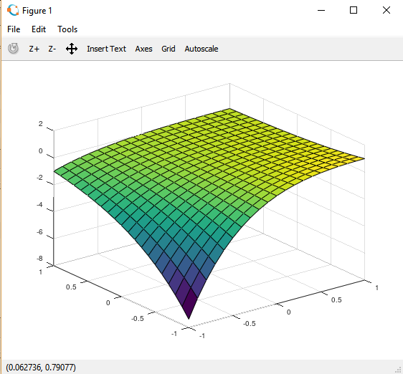

**3. Write a script to apply if and if-else statements.**

Here we are measured the boiling point of water.If it is equal to 100 degree centigrade then water will boil and if it is less than required limit then water will not boil.

function bp =boilingpoint()

val = input(' enter boiling point of water is 100 degree centigrade: ');

if (val == 100)

disp('water will boil.')

else

if (val < 100)

disp('water will not boil.')

end

end

end

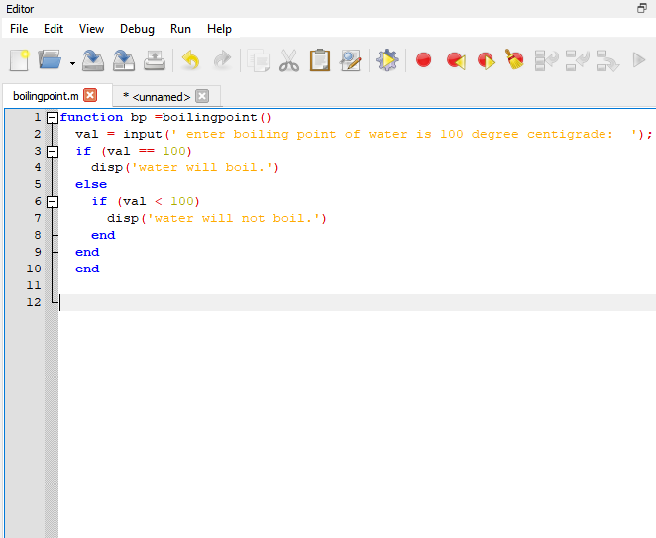

Results:

>> boilingpoint

enter boiling point of water is 100 degree centigrade: 100

water will boil.

>> boilingpoint

enter boiling point of water is 100 degree centigrade: 68

water will not boil.

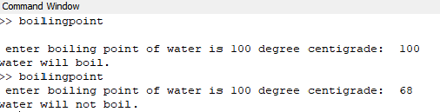

**4.Write a script to apply conditional logic switch.**

Here we all calculating number of people and their group as well. if the people are 15 then they belong to group A and if they 19 they belong to group B.

function cp = people()

val = input('enter the number of people: ');

switch val

case 15

cp = 'A'

case 19

cp = 'B'

otherwise

cp = 'not recoginzed'

endswitch

endfunction

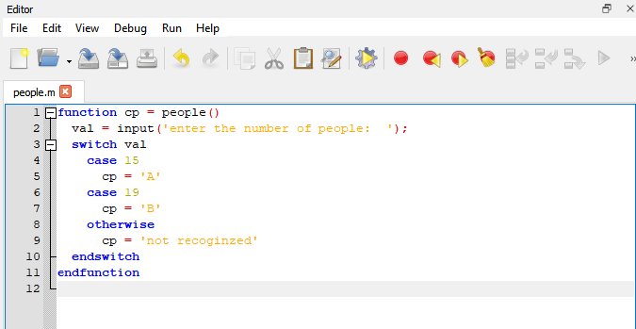

Results:

>> people

enter the number of people: 15

cp = A

ans = A

>> people

enter the number of people: 19

cp = B

ans = B

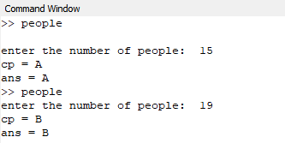

**5. Write a script to perform loop with a while condition**

Initially value of n is 2 and each time it increases by one only when its value is less than 9 .

n = 2;

while n<9

n = n+1

endwhile

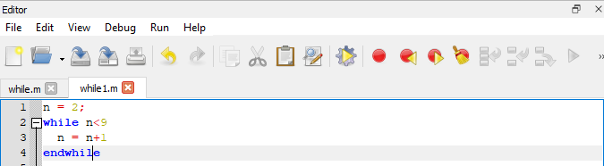

Results:

>> while1

n = 3

n = 4

n = 5

n = 6

n = 7

n = 8

n = 9

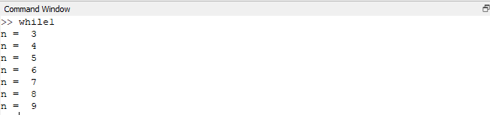

**6. Write a script to plot a vector of random data. Draw a horizontal line at the mean. Save the script and run it from the command line.**

n=25;

a=randn(n,1);

plot(a)

p = mean(a)

hold on

plot([0,n],[p,p])

hold off

title('mean :')

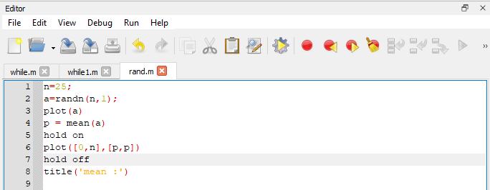

Results:

>> rand

p = -0.26873

>> rand

p = -0.64055

>> rand

p = -0.20697

>> rand

p = 0.13413

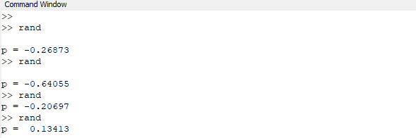

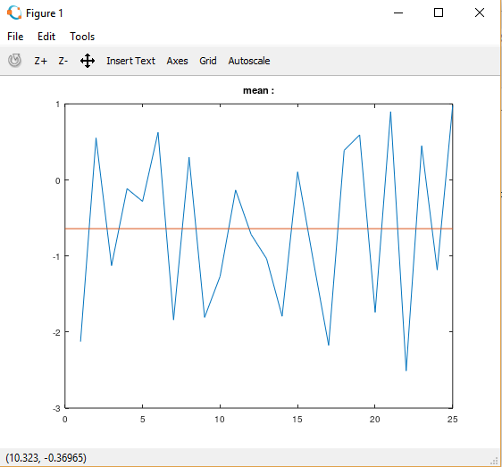

**7.** **Write a script that calculates the mean of five samples of data from a vector of random data. Calculate the overall mean. Use a for loop to perform the calculations. For each iteration of the loop print out the intermediate results. Use an if else control block to display the results depending on whether the mean of the samples is less than, greater than or equal to the overall mean.**

S=[1 100]

M=mean(S)

for j=randi([1 100],3)

K=randi([1 100],1,5)

L=mean(K)

disp(L)

if(L>M)

disp("mean is greater than complete mean")

elseif(L<M)

disp("mean is less than the complete mean")

else

disp("means are equal to each other")

end

end

Results:

S =

1 100

M = 50.500

K =

76 30 24 89 96

L = 63

63

mean is greater than complete mean

K =

99 77 26 93 42

L = 67.400

67.400

mean is greater than complete mean

K =

86 42 45 30 2

L = 41

41

mean is less than the complete mean

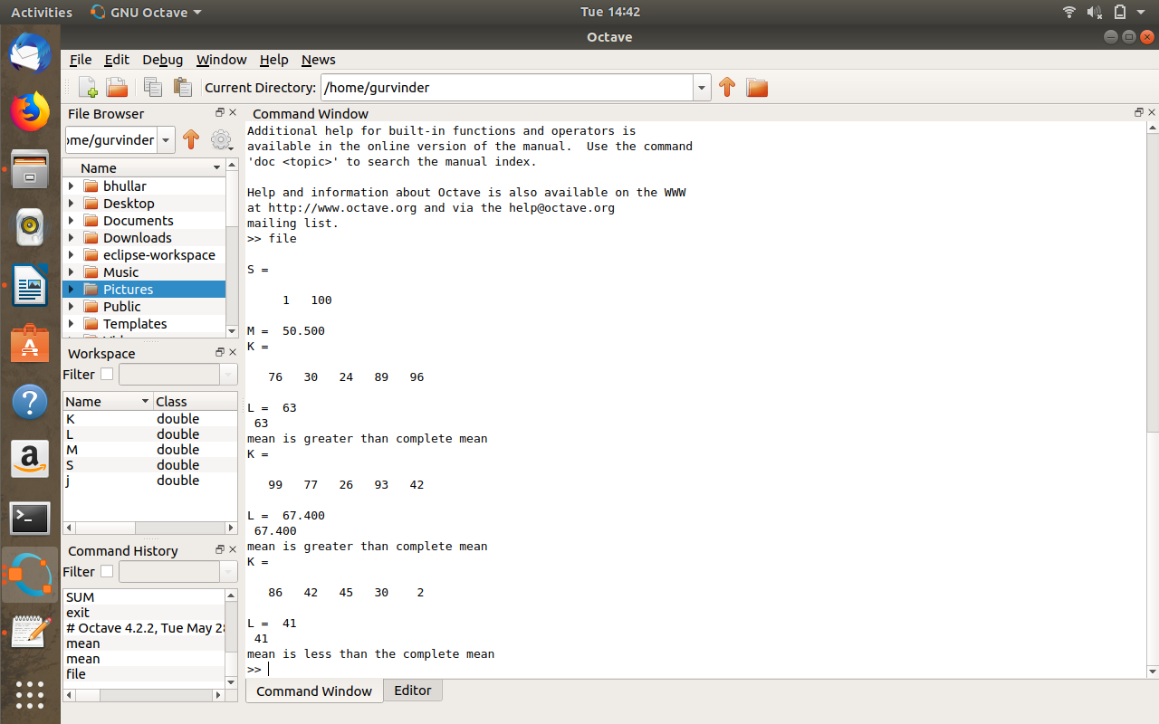

**8. Create a function that calculates the area of a circle with the radius as input in command window. Call this function from the MATLAB command line or in a MATLAB script (.m).**

function a =area()

r =input('enter tne radius:')

a = pi*r*r;

endfunction

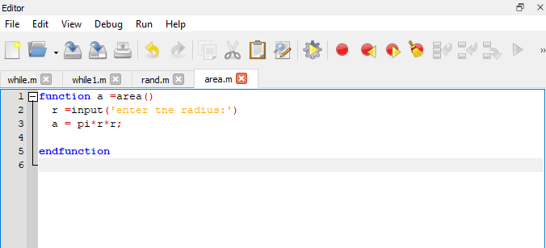

Results:

>> area

enter tne radius:5

r = 5

ans = 78.540

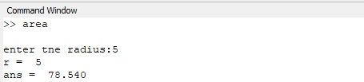

**9. Create a function that calculates the sum of an arbitrary number of sinusoidal terms. Call this function from the MATLAB command line or in a MATLAB script (.m).**

function K = Sum()

K = 20*sin(30)+40*sin(50)+60*sin(70);

end

function K = Sum()

K = 20*sin(30)+40*sin(50)+60*sin(70);

end

Results:

>> Sum1

ans = 16.178

